An Online Learning Platform with Intelligent Tutoring using AI Components

In this project we are employing machine and deep learning algorithm to search automatic learning tutoring. ML and DL algorithms get trained on tutoring material and then whenever user issue tutoring query then best performing algorithm will predict close matching tutoring with query and then suggest to user. User can read details online and can download tutoring materials.

For accurate prediction of tutoring we have experimented with various ML and DL algorithms like SVM, Decision Tree, Random Forest, Naïve Bayes and Convolution Neural Network (CNN). Each algorithm performance is evaluated in terms of Accuracy, Precision, Recall and FSCORE. Among all algorithms Random Forest and CNN performing

To implement this project we have designed following modules

1. Admin: admin can login to system using username and password as admin and admin and then can upload new material and can TRAIN all ML and DL algorithms model so user can perform search
2. User: user can sign up and login to system and then can enter query to search required tutoring material

To run project copy content from DB.txt file and then paste in MYSQL to create database and in database we added default 5 tutoring material and by using admin module you can add many more. Below is the DB file content

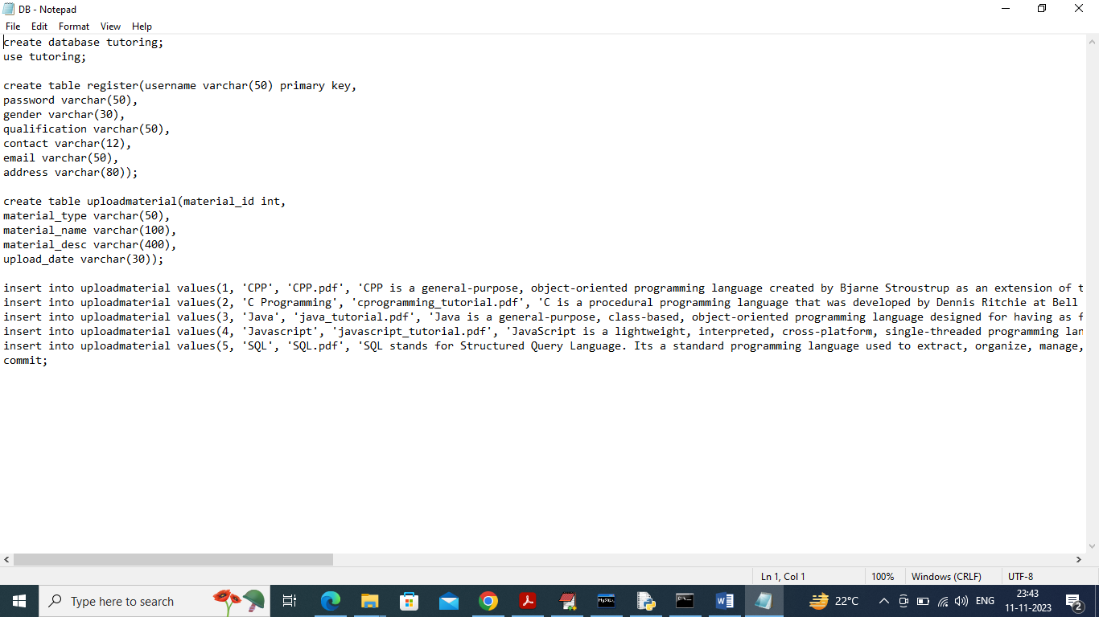

In above database file in last lines we are adding few tutoring materials.

SCREEN SHOTS

To run project double click on run.bat file to start python server and get below page

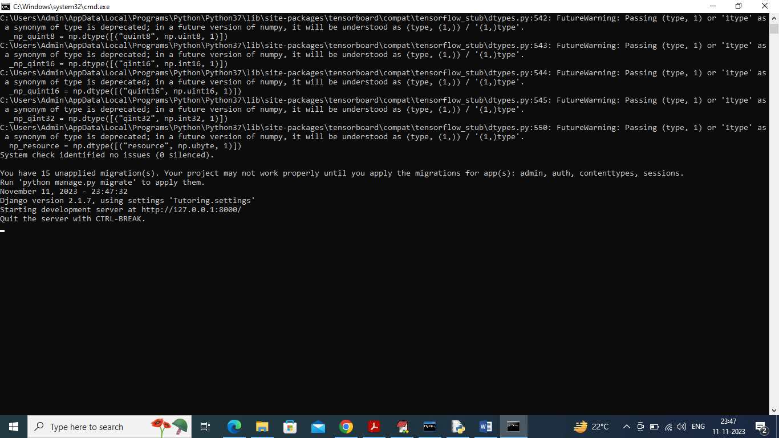

In above screen python server started and now open browser and enter URL as <http://127.0.0.1:8000/index.html> and press enter key to get below page

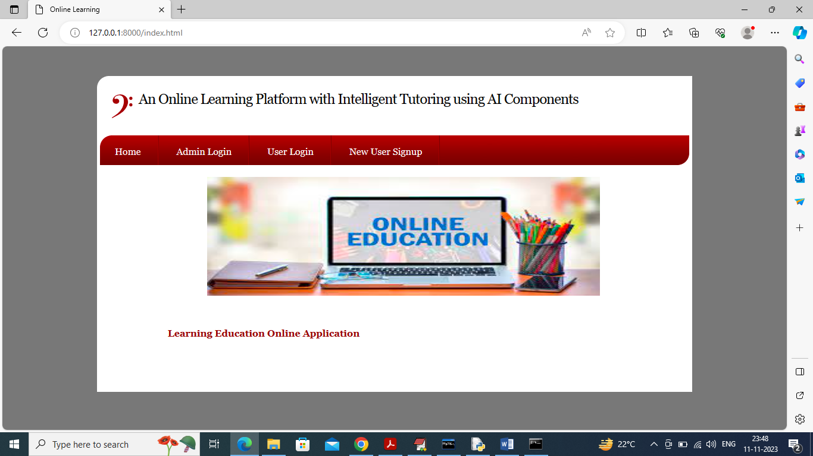

In above screen click on ‘Admin Login’ link to login as admin and get beloww page

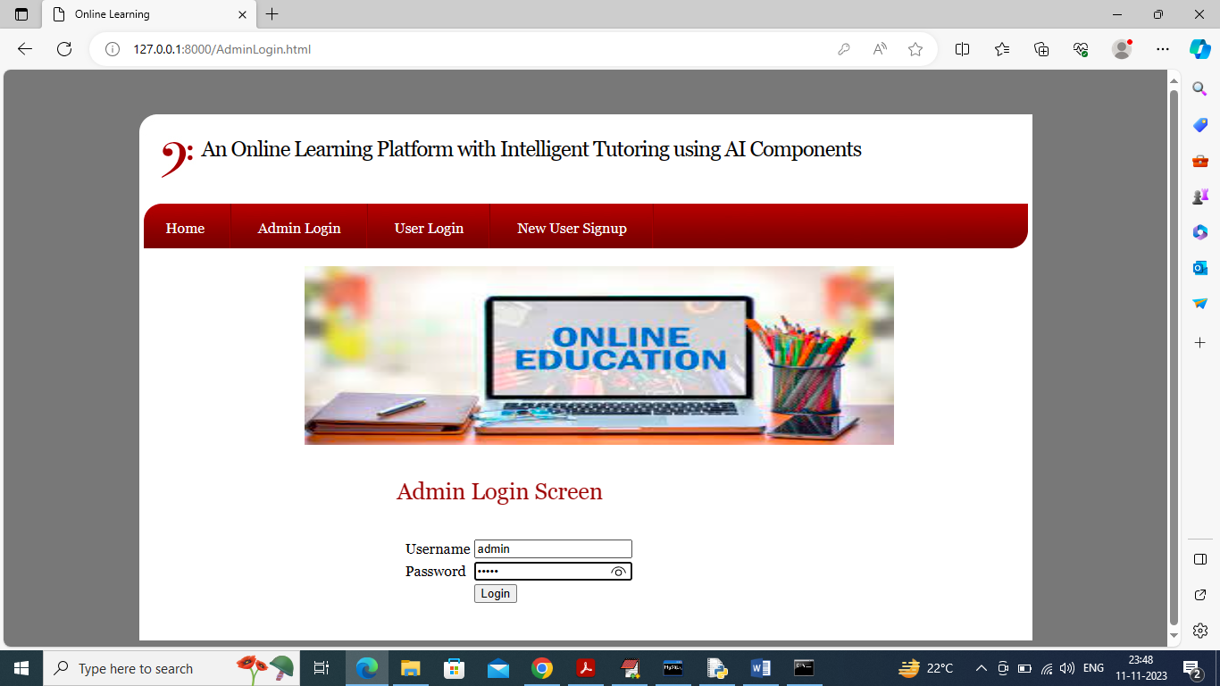

In above screen admin is login and after login will get below page

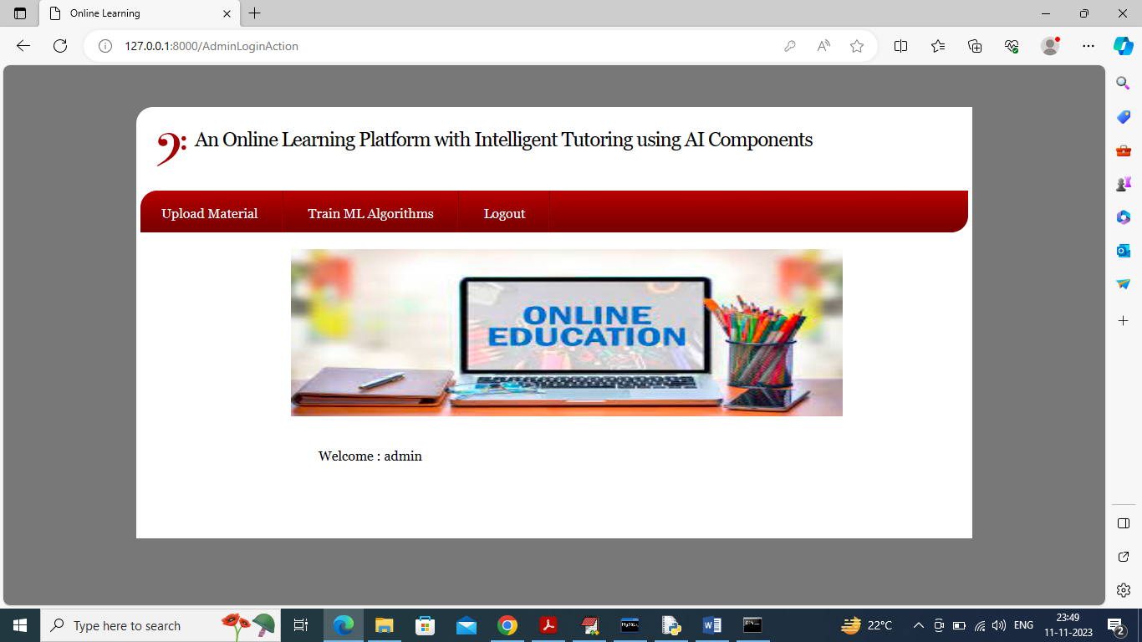

In above screen admin can click on ‘Upload Material’ link to get below page to upload material

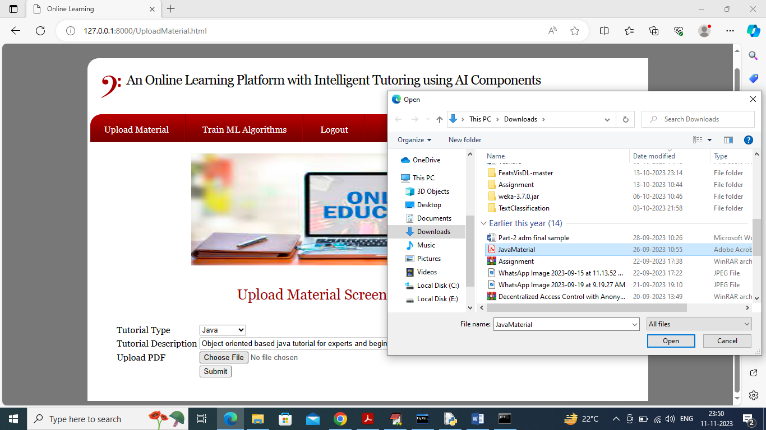

In above screen admin will select tutorial Type and then enter some description and then upload related material and then press ‘Open’ and ‘Submit’ button to save tutoring details and get below page

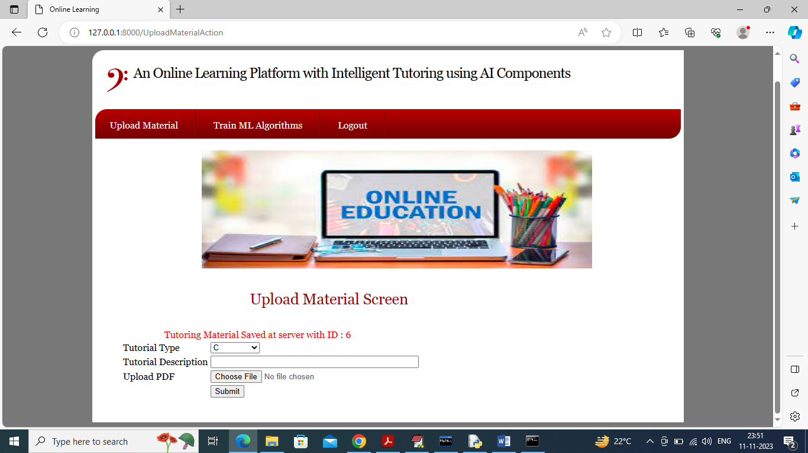

In above screen in red colour text can see ‘Tutoring Material saved in database’ and similarly you can upload any number of tutoring material. Now admin can click on ‘Train ML Algorithms’ link to train algorithms and get below page

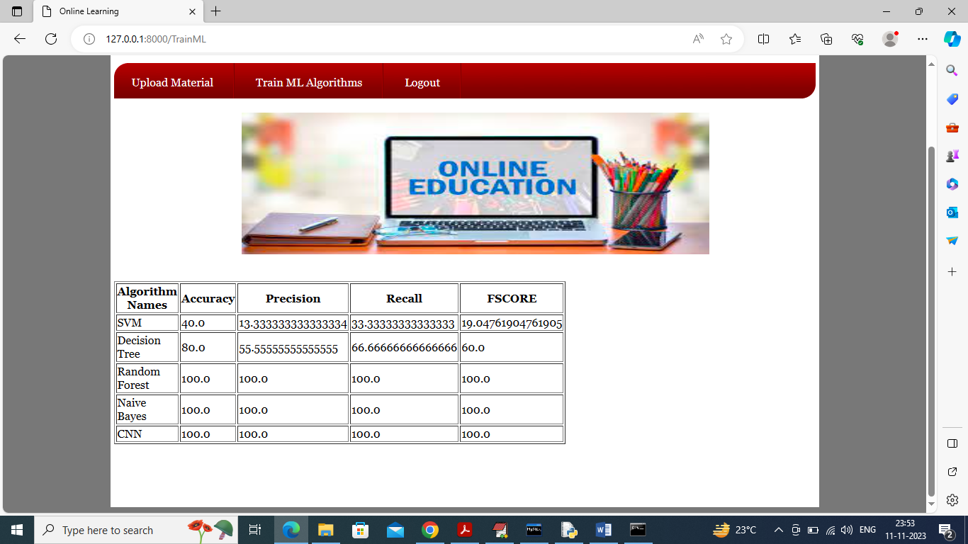

In above screen can see performance of each algorithm and to train all models we are splitting dataset randomly and we are taking 80% for training and 20% for testing so every time data changes and algorithm accuracy will vary. Now logout and sign up as new user

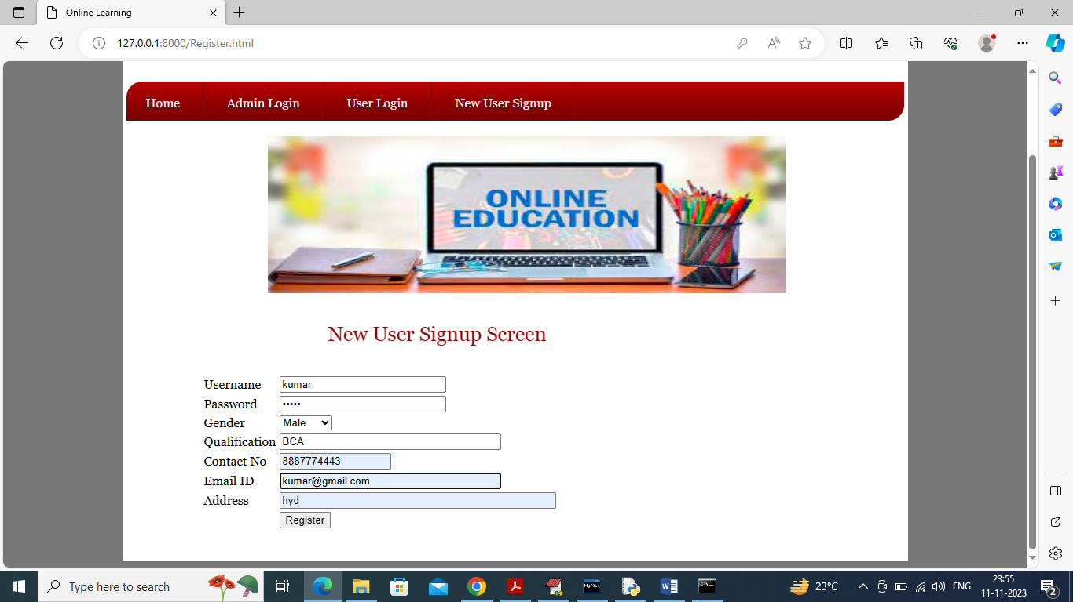

In above screen user is entering sign up details and then press button to get below page

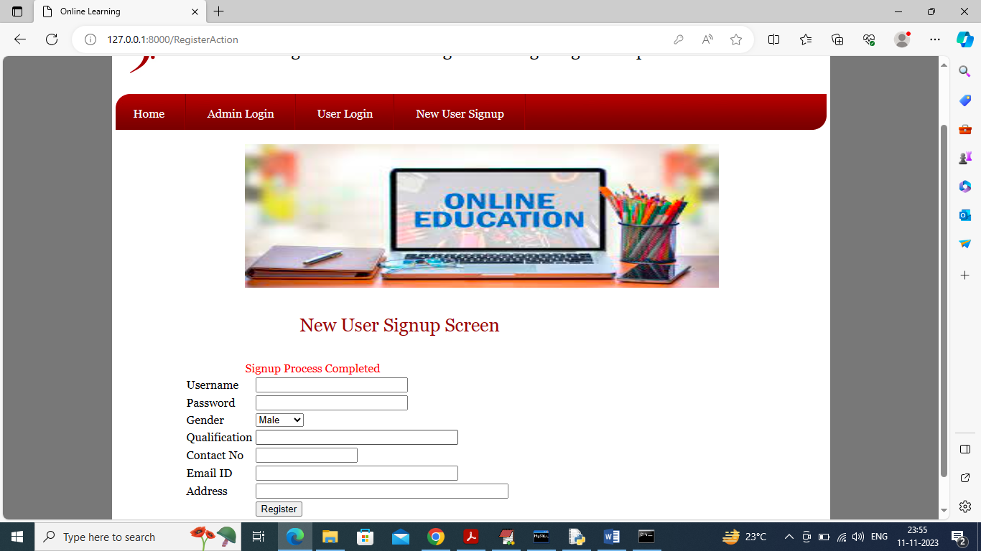

In above screen user sign up completed and now click on ‘User Login’ link to get below page

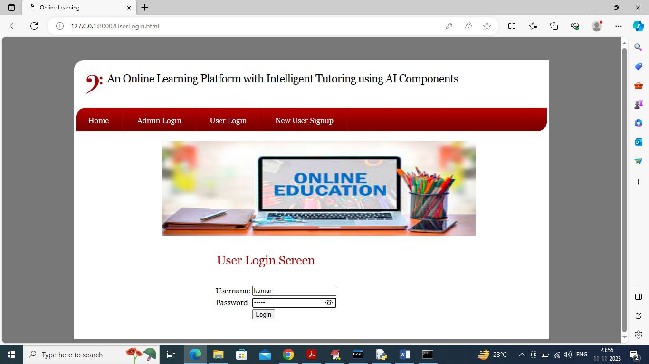

In above screen user is login and after login will get below page

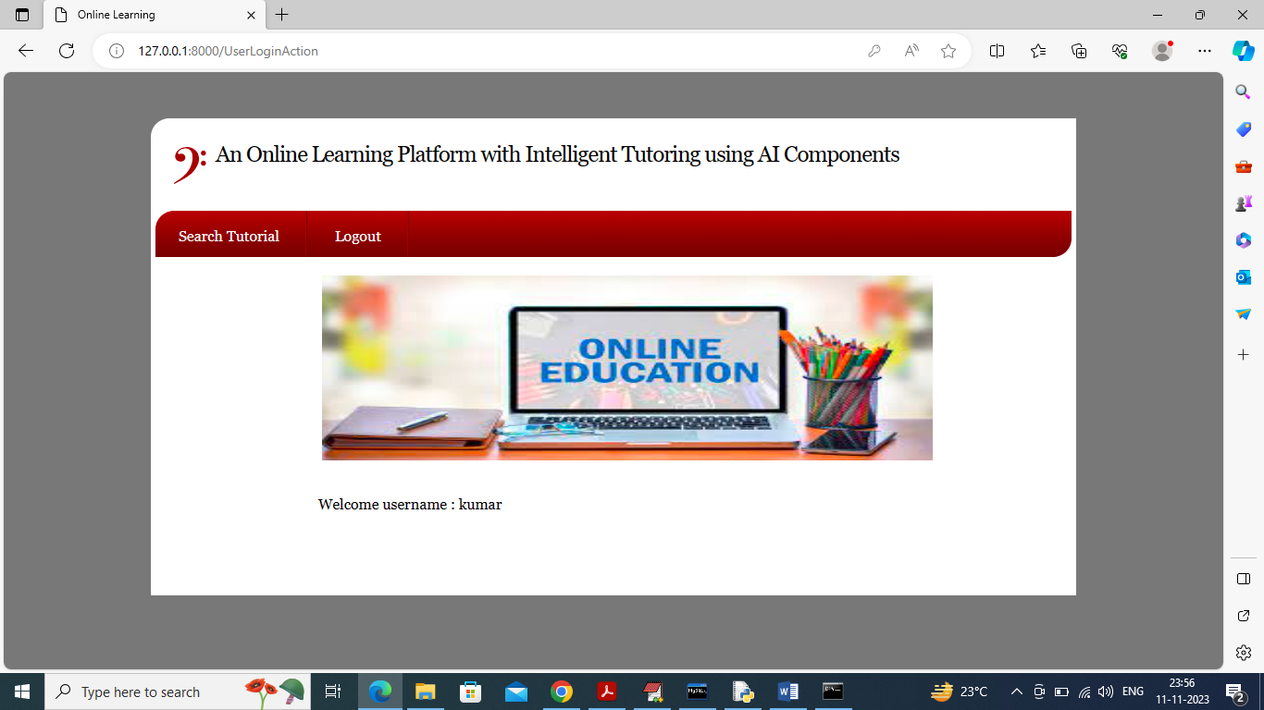

In above screen user can click on ‘Search Tutorial’ link to get below page

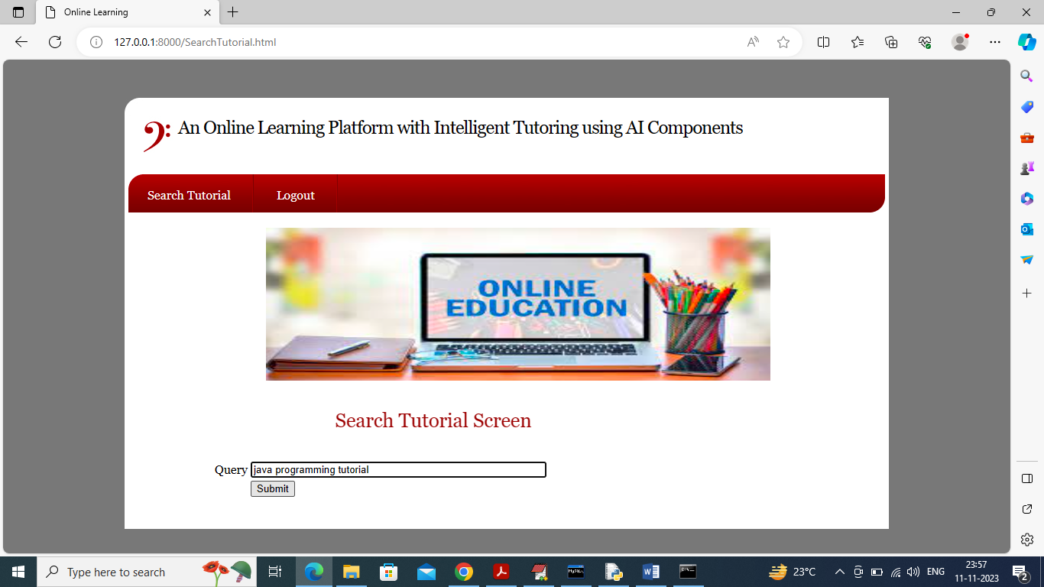

In above screen I am entering ‘some query for java tutoring’ and then press button to get below page

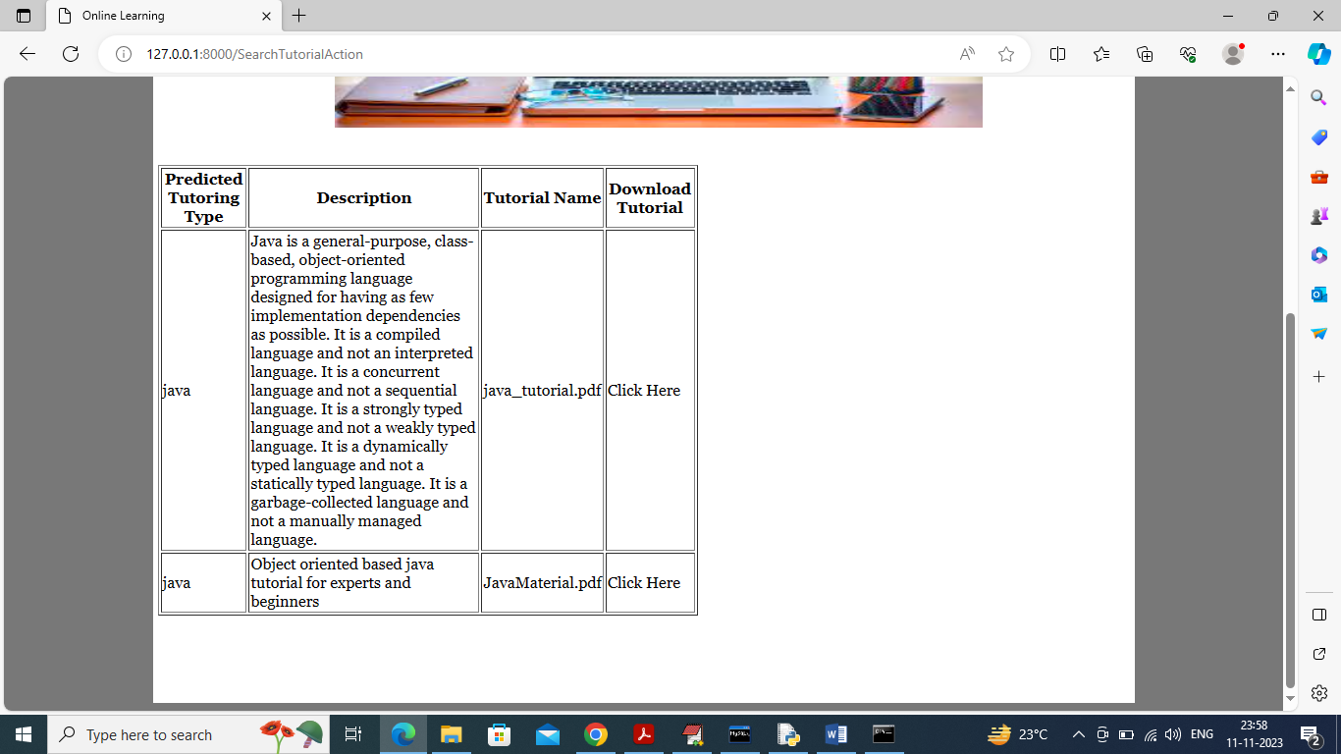

In above screen user can see tutorial description and then can click on ‘Click Here’ link to download that material and get below page

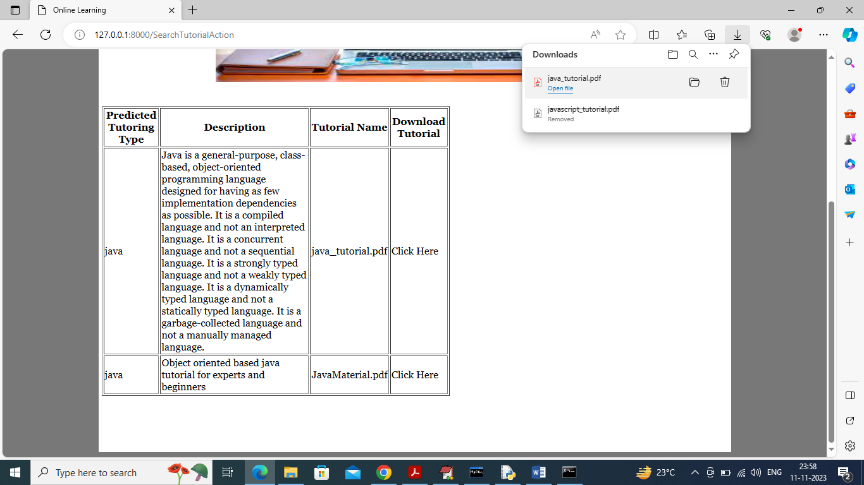

In above screen in browser download panel we can see tutorial file downloaded and similarly you can issue query and get result from best performing ML algorithms and below is another example

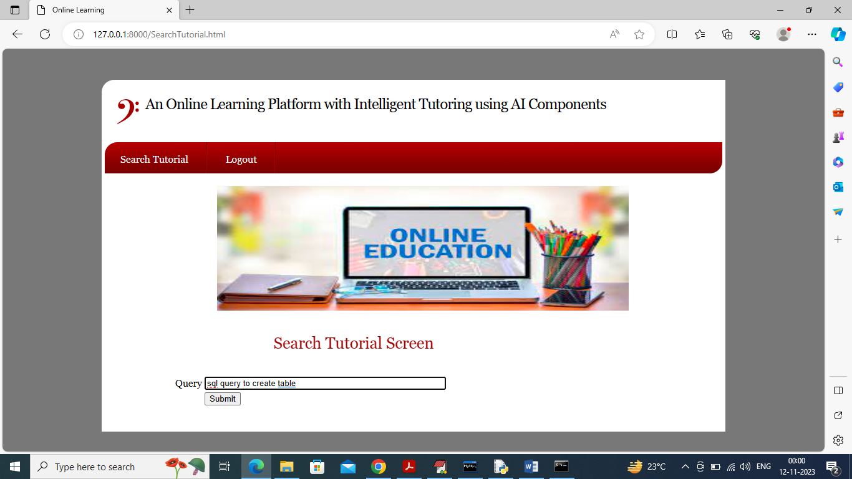

In above screen entering SQL query and then press button to get below page

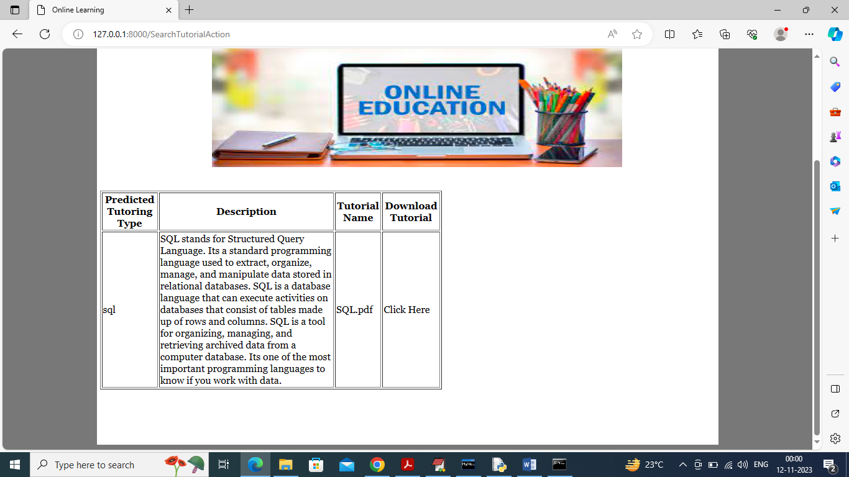

In above screen can see search result for ‘SQL’ queries

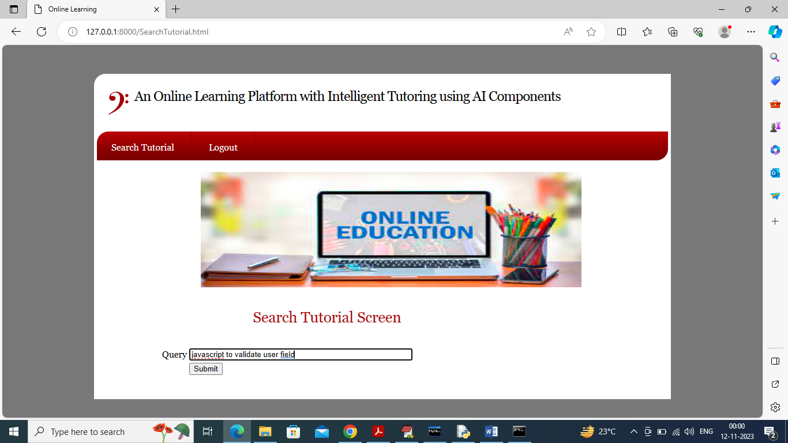

In above screen issuing query related to javascript and below is the output

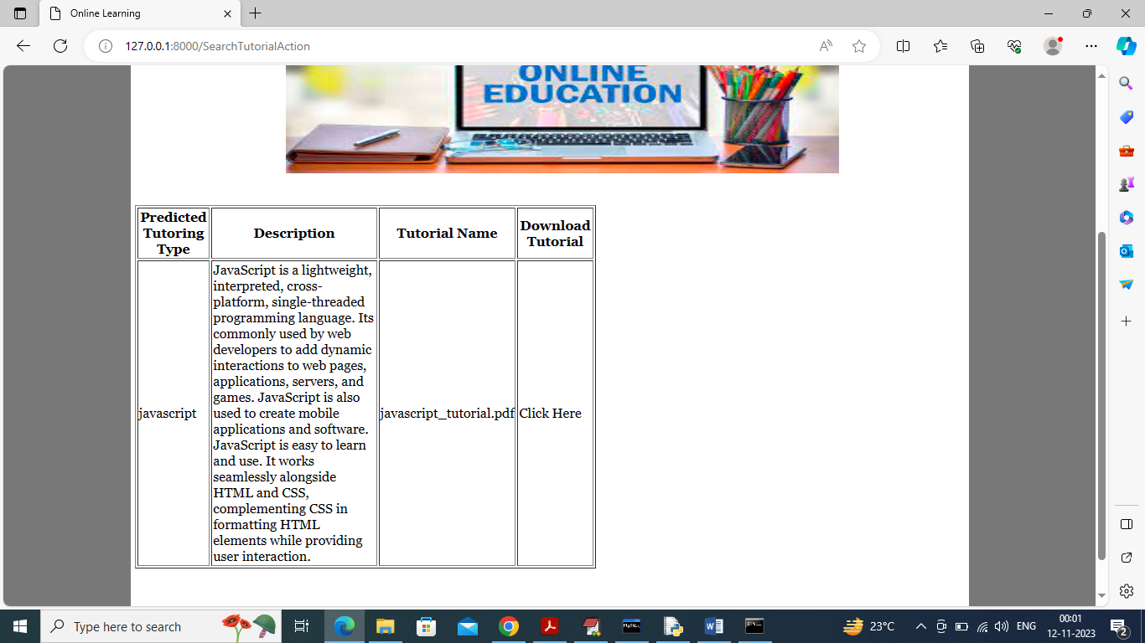

In above screen got output for javascript and similarly by following above screens you can upload and search tutoring material